VISBO Positioning
The Challenge for each Company
Companies, whether startups, small medium sized companies (SME) or large companies need to move fast and innovate – but they also need to stay compliant, structured, and audit-proof.
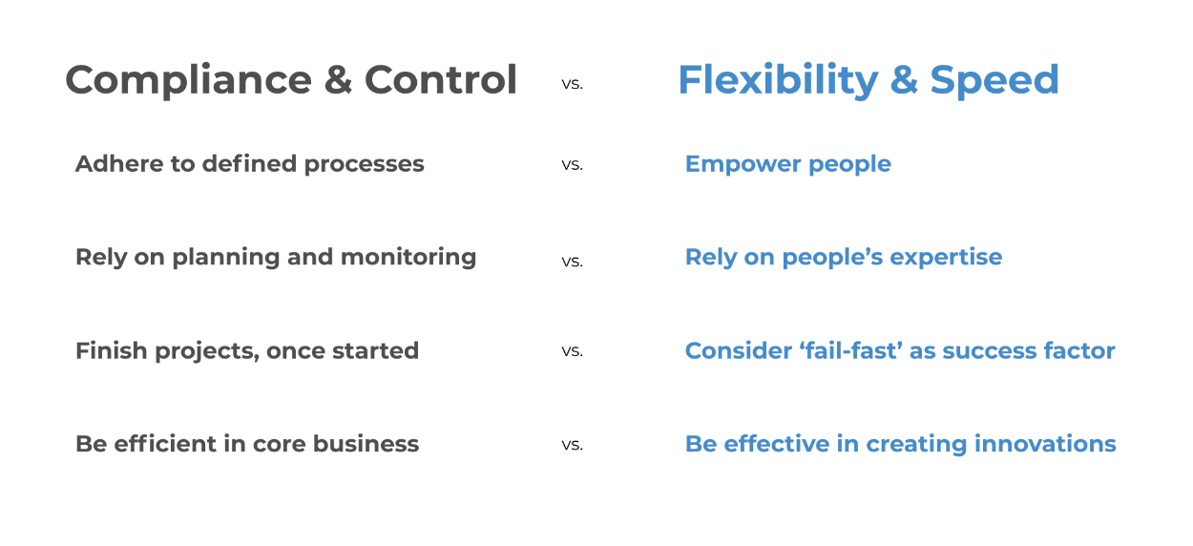
Each company has to find the right balance between these conflicting goals:
This is NOT an either-or choice. It is about both.
Startup companies and SME companies naturally first put focus on speed and flexibility. Over time and growing in headcount they need to add more and more process compliance and control.
On the other hand, larger corporations having established stringent processes focused on control and compliance are often looking for ways to achieve far more flexibility and speed.
No single system can fulfill both conflicting goals.
A 2-System Architecture enables organizations to act faster and more effectively in a complex world – without sacrificing order or compliance where it is necessary.

Recommended 2-System Architecture
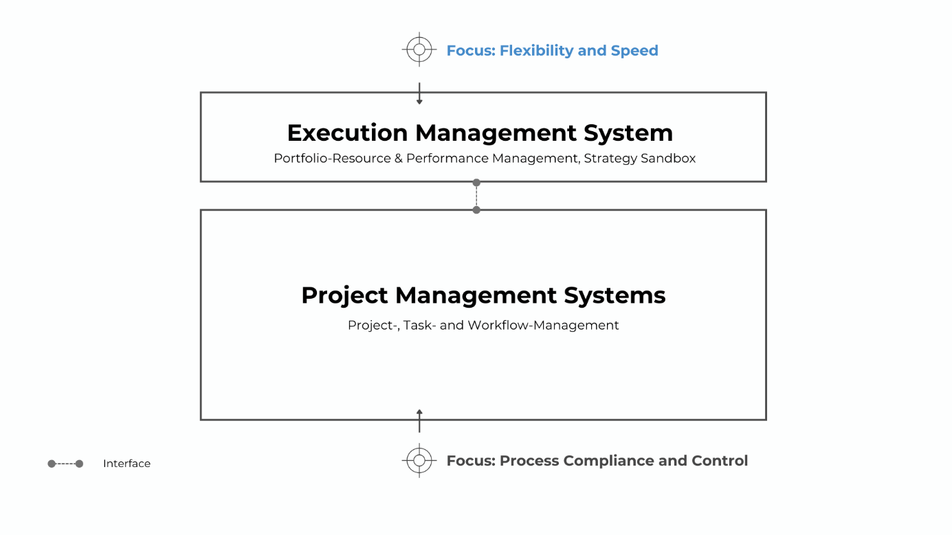Execution-Management-System
- Enterprise level resource management: Make sure, people are not overloaded by too many simultaneous projects and initiatives. Then projects are in flow and get finished faster. Thus, over a certain timeframe more projects can be done with the same people. We refer to this as „Productivity Mining“.
- Value and Performance Management: Make sure that the most valuable projects and initiatives are done. Monitor progress based on explicitly committed key data points of each project.
- Strategy Sandbox: Rapidly build plan variants and use what-if simulations to build and evaluate several scenarios in order to adapt faster to new circumstances and to optimize the value outcome for the enterprise.
Project-Management-System
- Project Management: Make sure, teams can plan and structure complex projects according their specific needs.
- Task- and Workflow Management: Offer teams a digital collaboration space with document management, task management and workflow automation.
- Ensure process compliance and line-of-control requirements as needed.

Key Advantages of a 2-System Architecture
1. Focus Instead of Compromise
- Project Management systems are strong in planning, documentation, compliance, and workflow control.
- Execution Management systems like VISBO are designed for prioritization, optimizing resource and team allocation and rapid scenario definition and evaluation.
- Each system can focus on what it does best – without compromise.
2. Productivity Gains Through Decoupling
- Operational bottlenecks often stem from portfolio overload, not poor project planning.
- VISBO helps identify overloads early and supports project prioritization what-if-simulations and AI-assisted project staggering.
- What-if Simulations are all done within the strategy Sandbox. The Project Management System remains untouched, until VISBO simulation results and findings are transferred to the Project Management System.
- Companies increase throughput per resource.
3. Flexibility Without Losing Control
- In large organizations, some areas require strict compliance (e.g., IT, regulated industries). But not every area needs the same level of control.
- With an execution management system such as VISBO, companies get overall adaptability and agility on enterprise level – while maintaining control with Project Management Systems in areas where it’s mandatory.
- The 2-system architecture enables differentiated governance by context and maturity.
4. Fast Return on Invest
- The VISBO Execution Management System can be introduced quickly – just importing plain Excel data.
- First results (e.g., people overload hotspots) are visible within days.
- The ROI often becomes measurable within a few months.

VISBO is about Execution Management.
VISBO is pure Execution Management with focus on enterprise flexibility, speed and value optimization.
VISBO holds timestamped, committed key data of each project plus the information about the overall available resource pool and skills of internal and external people.
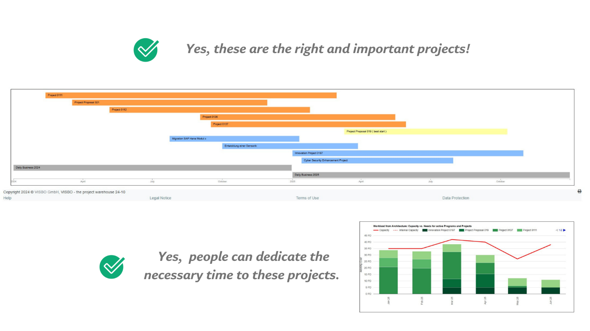

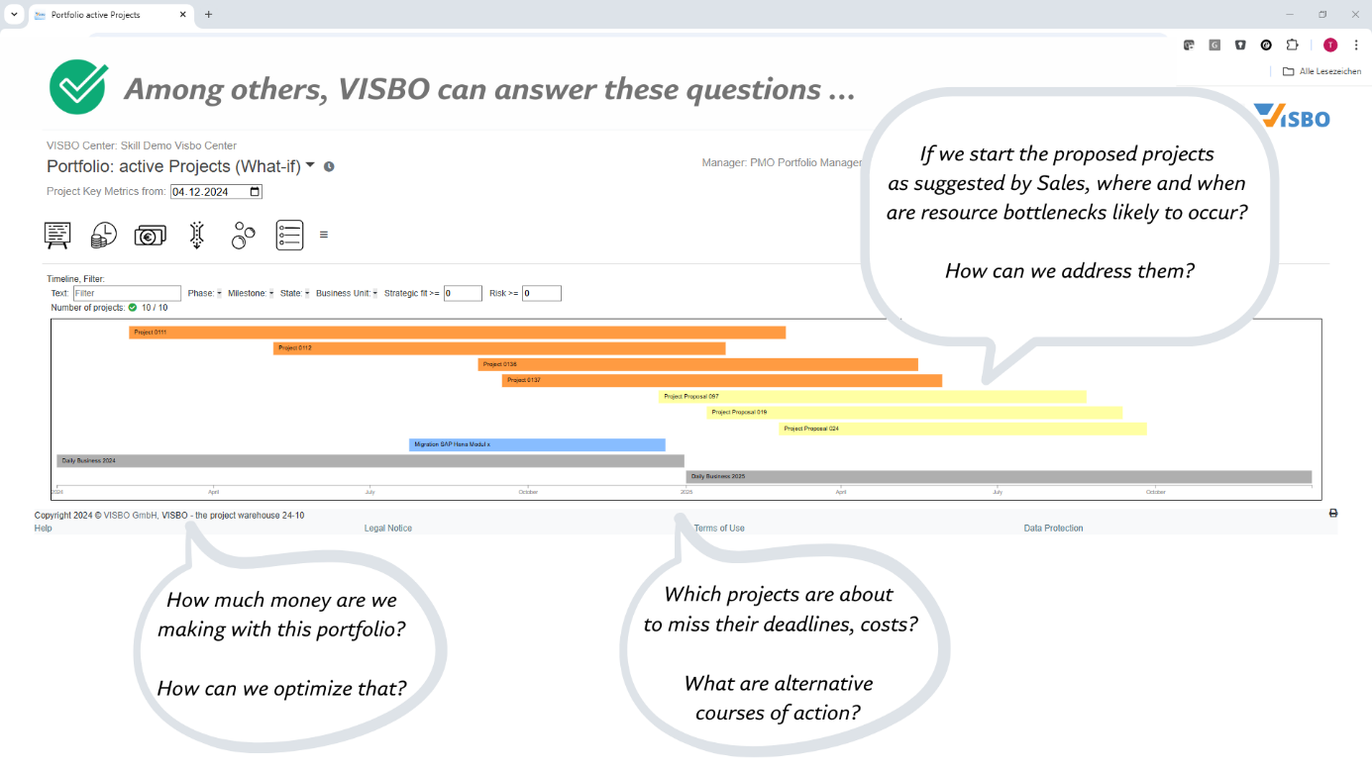
Recommendation
Startups and Small-and-Medium-Size companies (SME)
For companies starting on a green field, we recommend to start with an Execution-Management-System. The according database can be built within days, based on Excel data or project managers committed estimations according best knowledge and belief. This enables companies to start with portfolio resource management to quickly identify and overcome productivity barriers such as people overloading.
In a second step, companies can select in which areas and business units they need more detailed planning and monitoring. Then an appropriate Project Management (PM) tool and proces can be implemented. Using the VISBO ReST API, PM-tools can be integrated with the VISBO Execution-Management-System.
Large corporations
Large corporations have already built and defined processes for Project Management (PM) methods and have implemented PPM tools. Yet, very often companies are looking for more flexibility and speed.
By adding an Execution-Management-System to their existing PM-systems and processes they are enabled to achieve more flexibility and speed without sacrificing control and compliance in areas where it is necessary and mandatory.

